**Phase 8: Data Management & Deployment**

**Introduction**

In this phase, we focus on **data handling** (import, export, deduplication, backup) and **deployment** (moving metadata from Dev/Sandbox to Production). The goal is to ensure clean data, reliable backups, and smooth deployments for the Phishing Awareness Training Tracker.

**1. Data Import Wizard**

The **Data Import Wizard** is used for importing small to medium datasets (up to 50,000 records). For our project, we used it to import initial Employee records.

**Steps:**

1. Go to **Setup → Data Import Wizard → Launch Wizard**.
2. Select the custom object **Employee__c**.
3. Upload the prepared Employees.csv file (with Employee Name, Email, Department, Status, Overall Training Score, Training Status, and Record Owner).
4. Map CSV fields to Salesforce fields.
5. Choose record owner option → “Use values from CSV” (we used Salesforce User Email).
6. Run Import → verify in **Employees tab**.

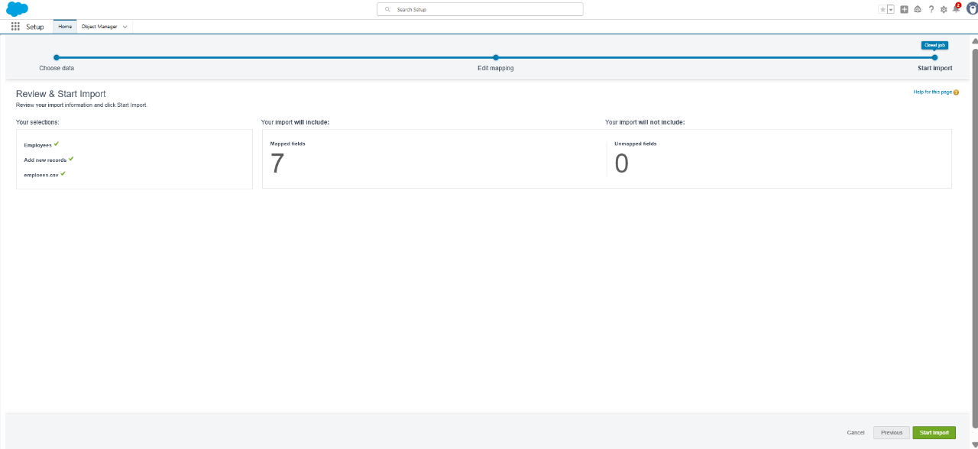

**2. Data Loader**

For larger datasets (above 50,000 records), **Data Loader** is used. In our project, this is useful for bulk imports of Assignments, Completions, and Simulation Results.

**Steps:**

1. Download & install Salesforce **Data Loader**.
2. Login with Salesforce credentials (Sandbox first).
3. Choose **Insert** operation.
4. Select object (e.g., Assignment__c).
5. Upload CSV file and map fields.
6. Run import and review logs for success/failure.

**3. Duplicate Rules**

To prevent duplicate Employee records (same email address), we created a **Matching Rule** and **Duplicate Rule**.

**Steps:**

1. Setup → Quick Find → **Matching Rules** → New.
   * Object: Employee__c.
   * Matching Field: Email__c.
   * Save & Activate.

1. Setup → Quick Find → **Duplicate Rules** → New.
   * Object: Employee__c.
   * Matching Rule: Employee_Email_ExactMatch.
   * Action: Block or Allow but Alert.
   * Save & Activate.

**4. Data Export & Backup**

Regular data backups are essential for compliance and recovery.

**Steps:**

1. Setup → Quick Find → **Data Export**.
2. Select objects: Employee__c, Assignment__c, Completion__c, Simulation_Result__c, Training_Module__c.
3. Schedule export weekly (e.g., Saturday at midnight).
4. Salesforce generates a .zip file and sends a download link via email.

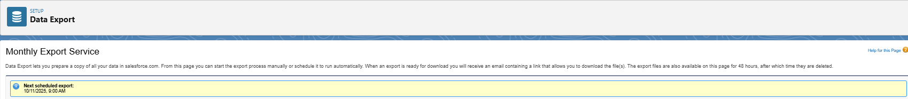

**5. Unmanaged vs Managed Packages**

For project sharing:

* **Unmanaged Package**: best for portfolios, training, and demos. Recipients can edit the components.
* **Managed Package**: locked, versioned, used for AppExchange distribution.

We used an **Unmanaged Package** for this project.

**6. SFDX & VS Code Deployment (Best Practice)**

While Change Sets are beginner-friendly, **Salesforce DX (SFDX)** with **VS Code** is best practice for developers.

**Steps:**

1. Install VS Code + Salesforce Extension Pack.
2. Authenticate Org:
3. sfdx auth:web:login -a DevOrg
4. Pull metadata:
5. sfdx force:source:pull
6. Deploy to target org:
7. sfdx force:source:deploy -p force-app
8. Track changes with GitHub for version control.

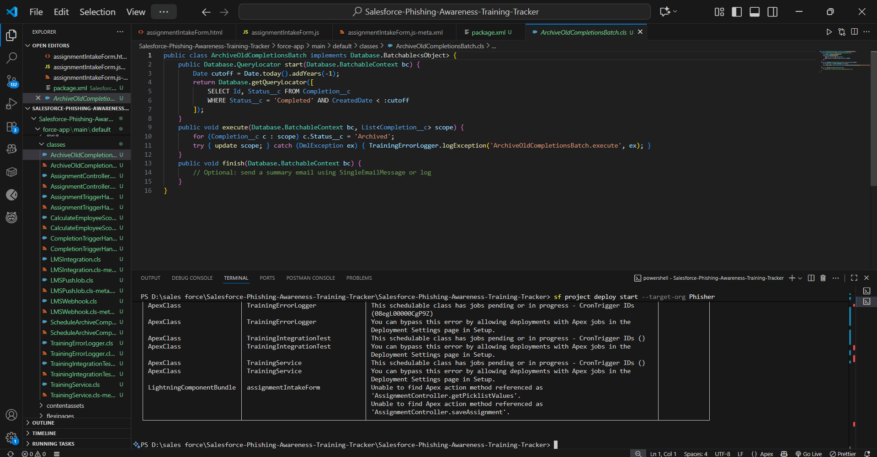

**Conclusion**

Phase 8 ensures that the Phishing Awareness Training Tracker is:

* **Data-ready** (imported & deduplicated),
* **Secure** (backups scheduled),
* **Deployment-ready** (Change Sets / Unmanaged Package / SFDX).

With clean data and reliable deployment methods, the project is now stable for production rollout.